

**Summer time maths**



**Simple games and activities to improve your child’s mental agility**

1. Play ‘ping pong’ to practise components with your child. You say a number or a decimal number and they reply with how much more is needed to make 1, 100 or 1000, 10,000 etc. Encourage your child to answer quickly without counting or using fingers.
2. Play Bingo. Each player chooses five answers. Ask a question and if a player has the

answer, they can cross it off. The winner is the first player to cross off all their

answers

1. Give your child an answer. Ask them to write as many number sentences as they can with this answer. You could just ask for addition sentences or any type of calculation.
2. Give your child a number fact – eg 5 + 8 = 13. Ask them what else they can find out from this fact – 50 + 80 = 130, 8 + 5 = 13, 13 – 8 = 5, 130 – 50 = 80, 0.5 + 0.8 =1.3 etc
3. **Guess my number**
4. Choose a number between 0 and 1 with one decimal place, e.g. 0.6.
5. Challenge your child to ask you questions to guess your number. You may only
6. answer ‘Yes’ or ‘No’. For example, they could ask questions like ‘Is it less than a half?’
7. See if your child can guess your number in fewer than 5 questions.
8. Now let your child choose a mystery number for you to guess.

Extend the game by choosing a number with one decimal place between 1 and 10, e.g. 3.6 (You may need more questions).

1. **Telephone challenges**
2. Challenge your child to find numbers where the digits add up to 42.
3. Find as many as possible in 10 minutes.

On another day, see if they can beat their previous total.

1. **Shopping**

* While shopping, point out an item costing less than £1.

Ask your child to work out in their head the cost of 3 items.

Ask them to guess first. See how close they come. If you see any offers labelled, (for example ‘2 for £3.50’) ask them to work out the cost of 1 item for you, and to explain how they got the answer.

* 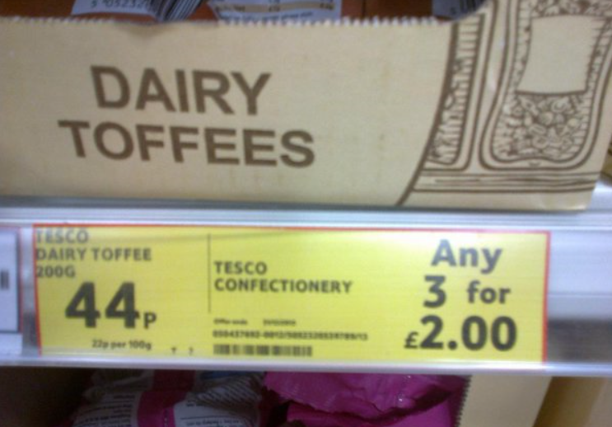Look at the special photo of a special offer. Is it really a special offer? Can you find any other examples like this? Take a photo and share with your teacher.

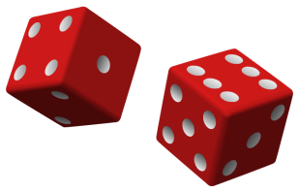

**Dice games**

1. Throw two dice. Ask your child to find the total of the numbers (+), the difference

between them (-) or the product (x).

Ask them to make a fraction. Where appropriate, simplify or change to a mixed number (eg 4/6 = 2/3 or 6/4 = 1 2/4 = 1 ½).



1. **Target 1000**
2. Roll a dice 6 times.
3. Use the six digits to make two three-digit numbers.
4. Add the two numbers together.
5. How close to 1000 can you get?
6. **Dicey subtractions**
7. a.) Take turns to roll a dice twice to make two 2-digit numbers. Subtract the smallest
8. from the largest.
9. b.) Use your dice or number cards to make two 3 or 4-digit numbers. Count on from

the smaller to the larger number, e.g *3995, 3996, 3997, 3998, 3999,*

1. *4000, 4001, 4002.*
2. You counted on 8, so you score 8 points.
3. Keep a running total of your score .
4. The person with the most points wins.

4) **Dicey division**

[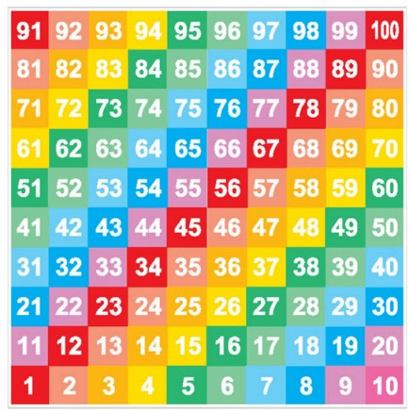](http://www.google.co.uk/url?sa=i&rct=j&q=&esrc=s&source=images&cd=&ved=0ahUKEwicv8mj79bNAhVUGsAKHVnvCcAQjRwIBw&url=http://www.thermoplasticlincolnshire.co.uk/numbergrids.html&bvm=bv.126130881,d.ZGg&psig=AFQjCNGHpiaj_t_XhdVnwL78c62YN5MEWQ&ust=1467620625460874)For this game you need a 1–100 board (a snakes and ladders board will do), a dice and 20 coins or counters.

Take turns. Choose a two-digit number. Roll a dice. If you roll 1, roll again.

If your two-digit number divides exactly by the dice number, put a coin on your chosen two-digit number. Otherwise, miss that turn.

The first to get 10 counters on the board wins.



**Card games**

1. Use a set of playing cards (without the picture cards). Turn over two cards and ask your child to multiply the numbers. If they answer correctly, they keep the cards. How many cards can they collect in two minutes?
2. Play 24 with a pack of playing cards using all of them. You need 4 players each puts a card down and first one to make 24 using any or all of the 4 operations and using all or some of the cards. First one to make the number keeps all the cards. Eg you put down a Jack , 2 hearts, 7 spades and 2 clubs. You could say 2x Jack add 2 hearts.

[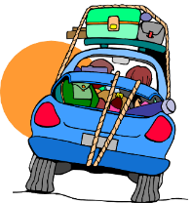](http://www.google.co.uk/url?sa=i&rct=j&q=&esrc=s&source=images&cd=&cad=rja&uact=8&ved=0ahUKEwjrju_Q8tbNAhXmA8AKHWOWD_IQjRwIBw&url=http://www.clipartpanda.com/categories/family-car-trip&bvm=bv.126130881,d.ZGg&psig=AFQjCNEgubqwdTWLZoPdt9aoSsV7Jdoykg&ust=1467621153369194)

**Games to play in the car**

Look out for car number plates.

* What is the number on the plate?
* What is this to the nearest 10 or 100 or 1000?
* How many more would you need to reach the next multiple of 10,100 or 1000?
* How many number plates can you spot with a prime number, square number, multiple of 5, factor of 48 etc?
* Choose 2 digits from a car registration plate. Make the smallest and largest numbers you can, each with 1 decimal place, e.g. 5.6 and 6.5.

Now find the difference between the two decimal numbers.

Whoever makes the biggest difference scores 10 points.

The person with the most points wins.

**FD56 UPN**

e.g. 6.5 – 5.6 = 0.9.

Play the game again, but this time score 10 points for the smallest difference, or 10 points for the biggest total (If you add the numbers).

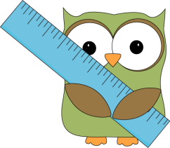

**Shape and measure activities**

1. Choose a shape of the week. Look for this shape in the environment. Ask your child to describe the shape to you.
2. Play ‘guess my shape’. You think of a shape. Your child asks questions to try to identify it but you can only answer ‘yes’ or ‘no’.
3. Hunt for right angles around your home. Can your child spot angles that are bigger or

smaller than a right angle? Do they know what these are called? (acute and obtuse)

1. Look for symmetrical objects. Help your child to paint or draw symmetrical

pictures/patterns.

1. Make a model using different boxes/containers of different sizes. Ask your child to

describe their model to you.

1. Practise measuring the lengths and heights of objects in metric measurements. Help your child use different rulers or tape measures correctly. Encourage them to estimate before measuring. Compare measurements in metric and imperial.
2. Let your child help with the cooking. Help them to measure ingredients accurately. Talk about what each division on a scale represents.
3. Choose some food items out of the cupboard. Try to put the objects in order of weight by feel alone. Then check by looking at the weights on the packets.
4. Practise telling the time with your child. Use both digital and analogue clocks. Ask your child to be a ‘timekeeper’ – e.g. tell me when it is half past four because we are going swimming.
5. Use a stop clock to time how long it takes to do everyday tasks –e.g. how long does it take to get dressed. Encourage your child to estimate first.
6. Use a TV guide. Ask your child to work out the length of their favourite programmes. Can they calculate how long they spend watching TV each day/week?
7. **Finding areas and perimeters**

*Perimeter = distance around the edge of a shape*

*Area of a rectangle = length x breadth (width)*

Collect 5 or 6 used envelopes of different sizes.

Ask your child to estimate the perimeter of each one to the nearest centimetre.

1. Write the estimate on the back.
2. Now measure. Write the estimate next to the measurement.
3. How close did your child get?

Now choose 5 or 6 adverts from newspapers or magazines.

You could do something similar using an old newspaper, e.g.

1. Ask your child to estimate the area of each advert to the nearest centimetre

squared – write these down.

Now measure and calculate. How close did your child get?

1. **Line it up**

You need a ruler marked in centimetres and millimetres.

1. Use the ruler to draw 10 different straight lines on a piece of paper.
2. Ask your child to estimate the length of each line and write the estimate on the
3. line.

Now give them the ruler and ask them to measure each line to the nearest

1. millimetre.
2. Ask them to write the measurement next to the estimate, and work out the
3. difference.
4. A difference of 5 millimetres or less scores 10 points. A difference of 1 centimetre
5. or less scores 5 points.
6. How close to 100 points can they get?

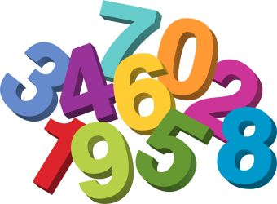

**More times tables practice. There can never be enough!**

1. Say together the six times table forwards, then backwards. Ask your child questions, such as: Nine sixes? How many sixes in 42? Six times four? Forty-eight divided by six? Three multiplied by six? Six times what equals sixty? Repeat with the seven, eight and nine times tables.
2. Make a times-table grid.

Shade in all the tables facts that your child knows, probably the 1s, 2s, 3s, 4s, 5s and

10s.

Some facts appear twice, e.g. 7 x 3 and 3 x 7, so cross out one of each.

Are you surprised how few facts are left?

There might only be 10 facts to learn. So take one fact a day and make up a silly

rhyme together to help your child to learn it, e.g. *nine sevens are sixty-three, let's*

*have lots of chips for tea!*

1. 5-second mental questions
   * What is 7 multiplied by 8?
   * Divide 64 by 8.
   * What is the product of 6 and 9?
   * What is 150 divided by 5?
   * How many 4s are there in 120?
   * Explain the strategies you used to answer these questions.
2. 10-second mental questions
   * What is 25 times 5?
   * What is 3 multiplied by 5 multiplied by 2?
   * How many 50s are there in 1000? How did you work this out?
3. 15-second mental questions
   * What is 300 divided by 15?
   * What is 0.7 × 5?
   * What other facts could you work out from 0.7 x 5?



**Problem solving with times tables knowledge**

* At the gym club there are two boys for every three girls. There are 30 children in the club. How many boys are there?
* 1/3 of 24 is equivalent to 24 ÷ 3. Write another fact like this one.
* What is 4/5 of 35?
* The perimeter of an equilateral triangle is 120 cm. How long is each side?
* Describe some connections between 6, 7 and 42, using the words *multiple* and *factor*.
* Write three different multiplications with a product of 40.
* Write three different divisions with a quotient of 9.
* If you multiply me by 3, you will get 24. What number am I?
* Multiples of 6 end in 0, 2, 4, 6 or 8. Is this statement true or false?
* Multiples of 7 are all even. True or false? How do you know?
* Name all the multiples of 9 between 80 and 100.
* Name three numbers that are multiples of 6 as well as multiples of 5.
* What is half of 6?
* What is 0.9 × 4? How did you work this out?
* Multiply 7 by 0.6.
* Divide 4.8 by 6.
* What is 4 × 0.7? How do you know?
* 0.15 ÷ 3 =
* What number multiplied by 8 equals 4.8?
* What multiplication and division facts do you know, or can you derive, with an answer of 5.6?
* What could the missing numbers be? box× box= 3.2   
  Can you think of several pairs of numbers that would work?
* Solve 2.8 ÷ box= 0.4.
* My pencil is 9.2 cm long. My desk is 6 pencil-lengths wide. How wide is the desk, in centimetres?
* Six packets of crisps cost £1.20. How much does each packet cost in £s?
* Explain how you would find half of 18.36.
* How many different multiplication and division facts can you find, using what you know about 72? What if you started with 7.2? 0.72?
* The answer to a multiplication or division calculation is 0.56. What could the calculation be? How many possibilities can you find?
* Are any of the following incorrect?  
  0.7 × 0.8 = 5.6  
  8 × 0.8 = 6.4  
  56 ÷ 0.7 = 8  
  Explain why and how you know, using words or diagrams.